**Project 2: Chapters 1-3**

1. show from the command line a connection to a db.

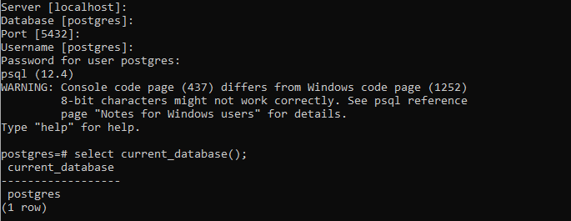

1. show user information

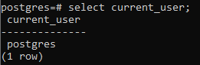

1. show IP and PORT of server

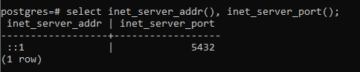

1. show version of server running

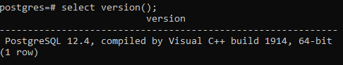

1. set your server to use a secure file for the password (pg 40)

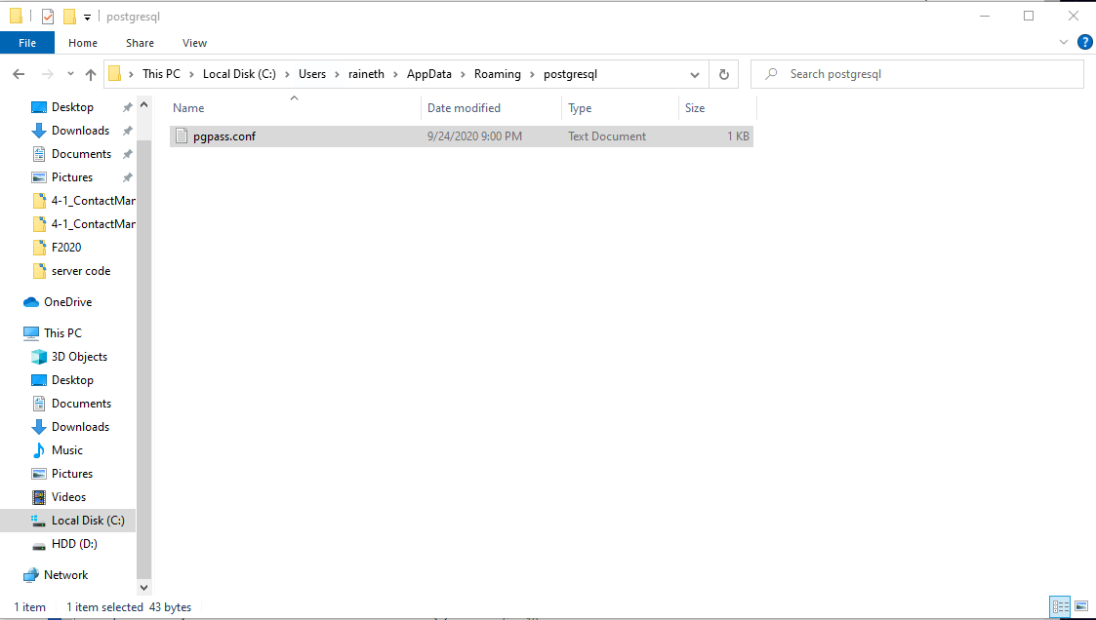

1. show your server using an environmental variable named PGPASSFILE

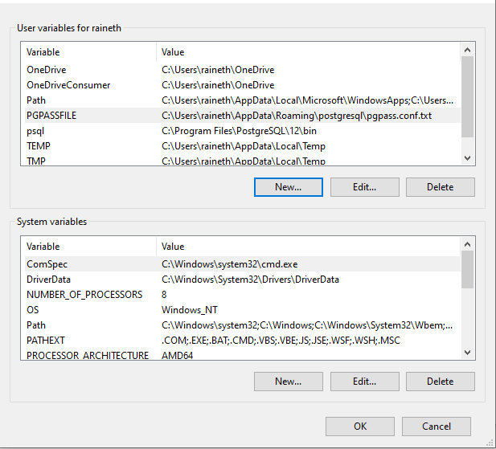

1. show uptime for your server, execute command twice to show time changing

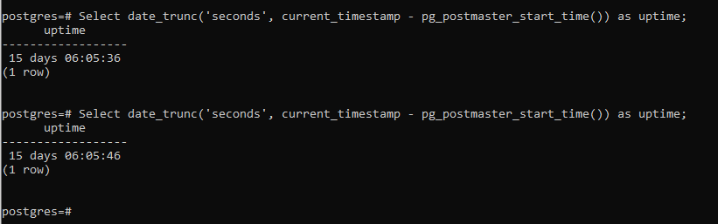

1. show database server message log output



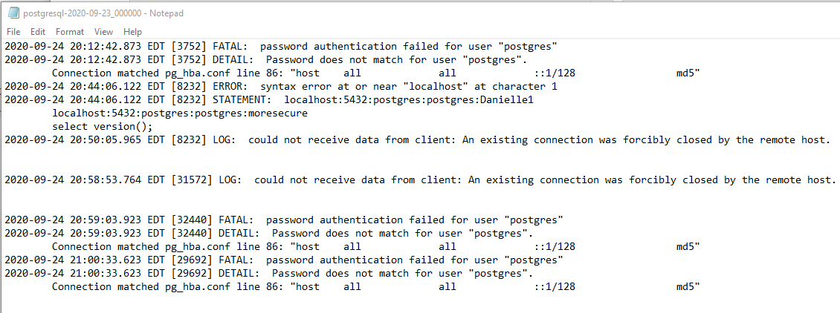

1. show server identifier